GNFA Food Service & Catering Department

As of January 1st, 2025

To whom it may concern:

New Policy regarding using 2025 Approved Caterer for Event

* All Food orders will be placed by Tawny Glass GNFA Catering Manager Contact information below.
* She will ensure the quote is given & you the Customer agrees with quote.
* Tawny will send Contract to both you the Customer & Approved Caterer requested.
* Payment for said Catered Meal will be paid by GNFA Food Service Department.
* You the Customer will see Line Items with Final Bill:

Catered Meal Cost

7% Sales Tax

15% Approved Caterer Fee

Tawny Glass

401 Larry Walker Parkway Suite E.

tglass@gnfa.com

478-224-3942office

478-244-7967cell



**GEORGIA NATIONAL FAIRGROUNDS & AGRICENTER**

**401 LARRY WALKER PARKWAY**

**PERRY, GEORGIA 31069**

**2025 APPROVED LIST OF CATERERS**

**GNFA CATERING DEPARTMENT**

**tglass@gnfa.com**

478-224-3942

**The Butcher Shop**

**Creekside Catering**

**CHICK-FIL-A**

**Satterfield’s**

**JERSEY MIKE’S SUB**

**Morning to Morning**

**Bodega Brew**

**________________________________________________________________________**

**2025 Approved Bar Services**

**Customer Responsible for Booking Bar Service**

**Tipsy Peach Wine & Beer only Kaitlyn Sinyard 478-952-4264**

**Shells Full Bar Service Marcus Hancock 912-310-9087**

|  |
| --- |
| **Continental**  Orange Juice  **Continental**  Orange Juice  Assorted Pastries  Butter and Assorted Jam  Coffee, Decaf  **$8.95** per person  Including Fresh Fruit **$9.95** per person    **Agility**  Assorted Bagels  Fresh Fruit  Assorted Egg Bites **$11.95** per person  Jams & Butter  Coffee  Assorted Juices    **Buffet**  Scrambled Eggs  Bacon and Sausage  Buttered Grits  Home Fries  Biscuits & Gravy  Orange Juice  Coffee  **$13.95** per person  **A La Carte**  Chicken Biscuits **$59.95** per dozen  Sausage, Egg, and Cheese Biscuits **$69.95** per dozen  Assorted Danish **$30.00** per dozen  Donuts **$18.00** per dozen  Assorted Bagels **$36.00** per dozen  Assorted Muffins **$32.00** per dozen  Nae Naes Coffee Cake **$3.25** per person    **Quiche Lorraine**  *Light and Fluffy with Bacon, Cheese, and a Buttery Crust!*  Choice of Caesar or House Salad  Fresh Fruit Wedges  Key Lime Pie  Iced Tea and Coffee **$14.95 per person**  **Beverages**  Milk Half-pints **$ 3.00** each  Assorted Juices **$ 2.25** each  Bottled Water **$ 2.50** each  Assorted Soft Drinks **$ 1.55** each  Coffee—regular or decaf **$55.00** per Urn  Hot Tea **$15.00** per Air pot  Iced Tea, Lemonade, Fruit Punch **$15.00** per gallon      **Snacks**  Variety of Health Bars and Candy Price quoted accordingly  Assorted Dessert Bars **$36.00** per dozen  Brownies **$24.00** per dozen  Fresh Baked Cookies **$18.00** per dozen Snack Mix **$55.00** per order  Homeade Potato Chips (w/dip) $4**5.00** per order  Fancy Mixed Nuts **$65.00** per order |

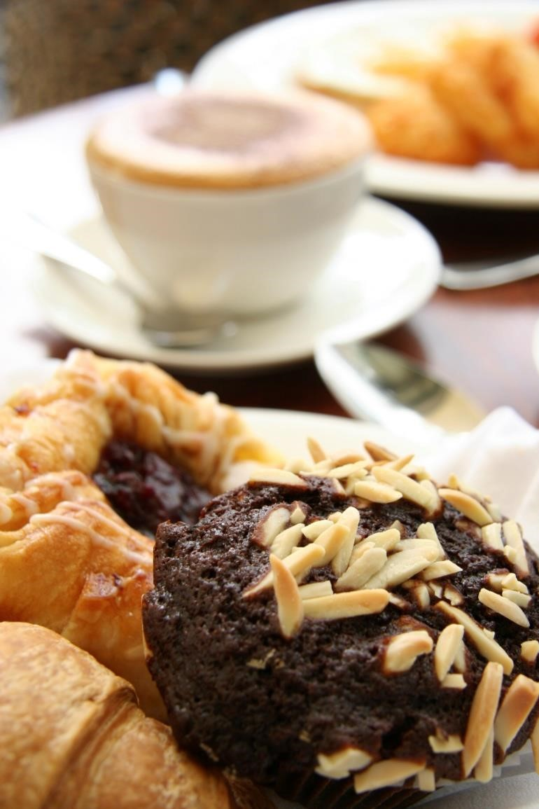

**GNFA Catering Department**

*Menus and Pricing are suggestive only*

*–*

*we are happy to*

*Customize menus and work within your budget.*

*Menu prices are subject to change.*

*Georgia Sales Tax*

*are in addition to the above prices*

*.*

*For availability*

*and*

*facility tour*

*s*

*, please call Tawny Glass*

***478***

***-***

***224***

***-***

***/***

***3942***

***tglass***

***@gnfa.com***



BREAKFAST

& REFRESHMENT BREAKS

|  |
| --- |
| **Grilled Chicken Box Lunch Special**  4oz. Chicken Breast Sandwich served with Lettuce, Tomato, and Pickle Spear,  choice of Pasta Salad, Potato Salad  choice of a Cookie or Brownie.  **$10.95 per person**    ***Sandwich, Chips, and Cookie:***  **$9.95 per person**    ***Chicken Biscuit, Chips, and Cookie:***  **$8.45 per person**    **Deli Bar**  Honey Ham, Smoked Turkey  Assorted Cheese Slices  Croissant or Sub Rolls  Lettuce, Tomato, Onion and Pickle Spears  Pasta Salad, Potato Salad, Fresh Fruit or Broccoli Salad  (pick 2)  Assorted Gourmet Cookies and Fudge Brownies  Iced Tea or Lemonade **$15.45 per person**    **House Salad**  Mixed Greens, Sharp Cheddar Cheese, Bacon, Tomatoes, Red  Onion and Seasoned Croutons, served with your choice of  Ranch, Blue Cheese, Balsamic Vinaigrette or Honey Mustard Dressing  **$10.95 per person**    **Chef Salad**  Mixed Greens, Swiss Cheese, Ham, Turkey, Tomatoes,  Cucumbers, Red Onion, Hard-boiled Egg, and Seasoned  Croutons served with your choice of Ranch, Blue Cheese, Balsamic Vinaigrette or Honey Mustard Dressing  **$12.45 per person**    **Box Lunch**  Choice of:  Smoked Turkey Club  Ham & Cheese  Italian Submarine  Chicken  Tuna Salad  Chicken Caesar Wrap  Veggie Wrap  Chef Salad  Served on a Croissant or Sub Roll  Lettuce, Tomato and Pickle Spear  Choice of Pasta, Potato Salad, Broccoli Salad  Fresh Fruit  Potato Chips  Cookie or Brownie **$14.95 per person**        *We do provide gluten-free options!* |

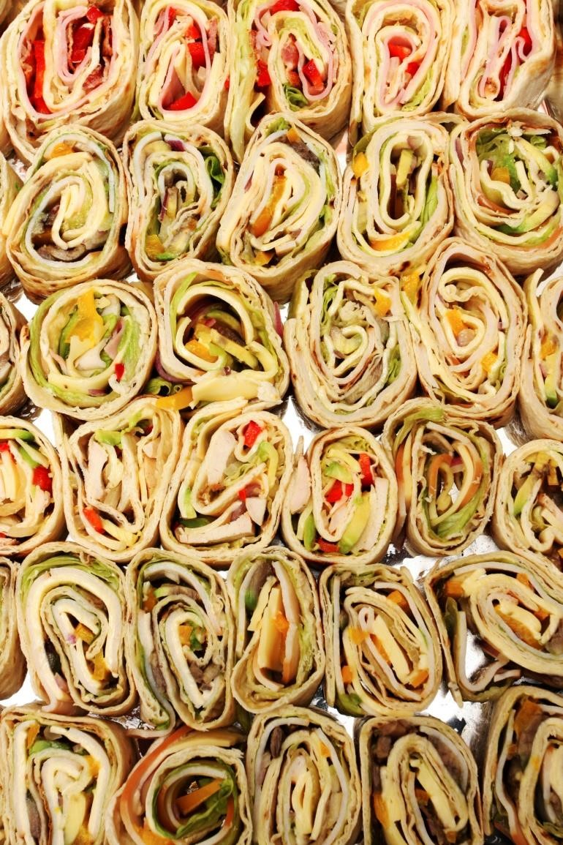

**GNFA Catering Department**

*tglass@gnfa.com*

*4782243942*

*-*

*-*



LUNCHEON

& BOX LUNCHES

|  |
| --- |
| **Served Hot (Priced per 50 Servings)**  Cocktail Meatballs $165.00  Chicken Wings $175.00  Chicken Tenders $175.00  Mini Quesadillas $155.00  Spring Rolls $165.00  Barbecue Short Ribs $225.00  Sweet Potato Rounds with Goat Cheese $175.00  Franks in a Blanket $155.00  Scallops Wrapped in Bacon $225.00  Baked Brie with Roasted Walnuts or Pecans $155.00  Teriyaki Beef Kabobs $175.00  Teriyaki Chicken Kabobs $165.00  Crab-stuffed Mushroom Caps $175.00  Cream Cheese Jalapeno Poppers $145.00  Artichoke Spinach Dip $165.00  Sausage Balls $195.00  Candied Bacon $225.00            **Cold Services (Priced at 50 Servings**  Mini Croissant Sandwiches $175.00  Cold Antipasto Tray $245.00  Iced Crudités with Dip $145.00  Southern-style Deviled Eggs $155.00  Chocolate Dipped Strawberries $195.00  Crabmeat Pate $175.00  Fiesta Spread $125.00  Guacamole, Salsa, and Tortilla Chips $145.00  Vidalia Onion Spread $125.00  Key Lime Pimento Cheese Spread $125.00  Classic Cheese Ball $110.00  Salami Stacks $110.00  Buttery Toasted Pecans $125.00            **3 Tier Signature International Fruit & Cheese Display**  Priced according to Need          **Seafood\***  Jumbo Cocktail Shrimp  Lobster  Crab  Seafood Boil      *\* Seafood Pricing is customized, according to Market Price.* |

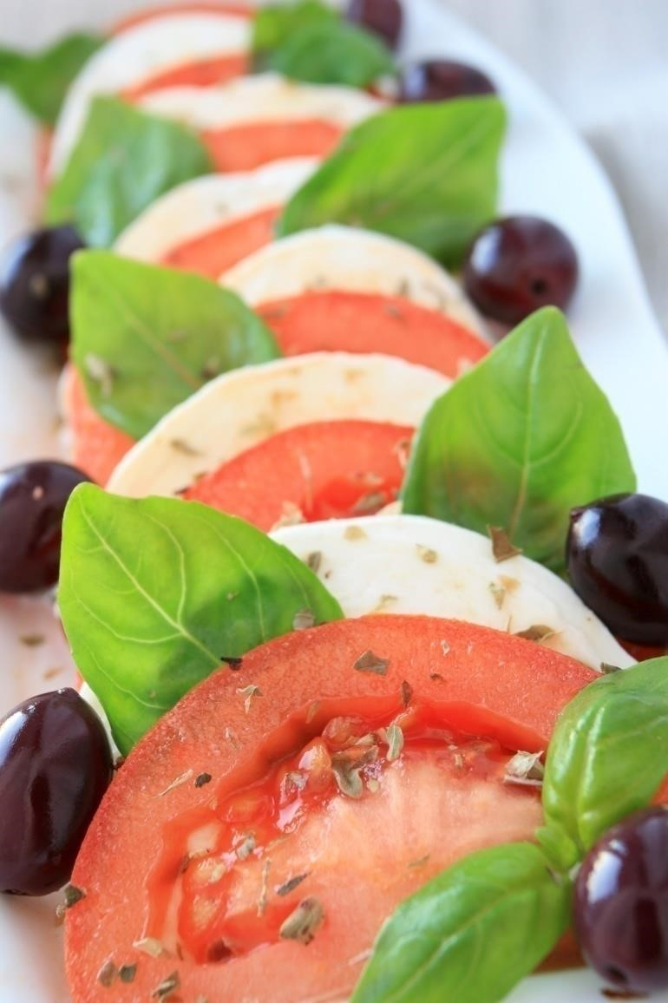



Standard Linens 19.00ea.

Plastic Table Covers 9.00

Custom Colors & Design Linens

Fresh Cut Flowers are Available in Season

Quoted accordingly to need



***-***

HORS D

’

OEUVRES

|  |  |  |  |
| --- | --- | --- | --- |
| ***GNFA Food Service & Catering***    ***Department*** | |  | | --- | | ***Dinner Entrées include:***  ***Choice of Salad, 2 Side Dishes, Dessert, Dinner Rolls***  ***Sweet & Un Sweet Tea & Water***    **Entrée Selections – Group 1**  Southern Fried Chicken Roasted Turkey  Slow Roasted Pot Roast Honey Glazed Ham  Old Fashioned Meatloaf Fried Catfish  Herb Roasted Chicken Beef Tips  Lasagna Pepper Steak  Pork Tenderloin  **One Entree $22.95** per person  **Two Entrees $ 25.95** per person    **Entrée Selections – Group 2**  Chicken Cordon Bleu Stuffed Flounder  London Broil Butterfly Fried Shrimp  Shrimp Scampi Chicken Marsala  Grilled or Fried Pork Chops Grilled Ribeye  Beef Tenderloin  **One Entrée: $26.95** per person  **Two Entrees:29.95** per person    **FULL TACO BAR 18.95** per person **(2024 Customer Favorite)**    **Vegan/Vegetarian Options: \***  Vegan Pasta and Asparagus with Lemon-butter  Mediterranean Buddha Bowl  Black Bean Soup/ Corn Tortillas  Spinach Artichoke Stuffed Peppers  Mushroom and Spinach White Pizza    **$18.95 Per Person**    **Gluten-free Options: \***  Pot Roast with Potatoes and Carrots  Pork with Squash and Kale  Beef Tenderloin with Roasted Red Grapes and Cabbage  Sesame Chicken, Zucchini, and Fried Potatoes  Tuscan Butter Salmon  Shrimp Salad with Crispy Chorizo and Almonds  Veggie Burgers  **$20.95 Per Person**      *Please note, most recipes, including many of the ones listed on our hors d’oeuvres menu, can be tweaked to accommodate the above dietary requests. This is a sample of our most popular items, and we are happy to make other suggestions and/or customize a different menu for you and your guests.    Gluten-free options are prepared in a common kitchen with the risk of gluten exposure. Therefore, we do not recommend these items for guests with celiac disease. If you or your guest have gluten sensitivities, please let us know so that we can work with you to provide an allergy safe meal. | | BUFFET DINNER  –    ENTREES |
|  |

|  |
| --- |
| ***Dinner Entrées include choice of salad, two Side Dishes, one Dessert, Dinner Rolls, Coffee, Iced Tea and Water. Selections may be found on the Side Dishes Menu as well as the Desserts Menu.***    **Choose One (1) of the Following Salads:**    Mixed Greens House Salad Caesar Salad  Spinach Salad Vinaigrette Caprese Salad  Broccoli Salad Cucumber and Tomato Salad  Pasta Salad Fresh Fruit Salad  Redskin Potato Salad Southern Style Cole Slaw  Peach Barretta Salad        **Choose Two (2) of the Following:**    Sweet Potato Rice Pilaf  Cheese Grits Cheesy Scalloped Potatoes  Baked Beans Roasted Brussel Sprouts  Sautéed Asparagus Macaroni & Cheese  Red Roasted Potatoes (w/ Zucchini, Squash, red Cherry Tomatoes)  Fettuccini Alfredo Mashed Potatoes with Gravy  Cornbread Dressing Italian Green Beans  California Blend Vegetables Buttered Corn  Turnip Greens June Peas with Mushrooms  Black-eyed Honey Glazed Carrots  Fried Okra Broccoli Casserole  Steamed Broccoli Lima Beans  Fresh Cabbage Collard Greens  Squash Casserole Corn Casserole  Baked Potato  **Desserts**  Signature Peach Cobbler Southern Pecan Pie  Assorted Cheesecake Carrot Cake  Key Lime Pie Chocolate Cake  German Chocolate Cake Red Velvet Cake  Tiramisu Rum Cake  Apple Dumpling Old Fashioned Apple Pie  Chocolate Delight Pudding Banana Pudding  Strawberry Shortcake Apple Crisp  Lemon Blueberry Bread Pumpkin Bread  * Chef’s Choice Assorted Dessert Table  **Ask us about Our Confection Items priced According to need** |

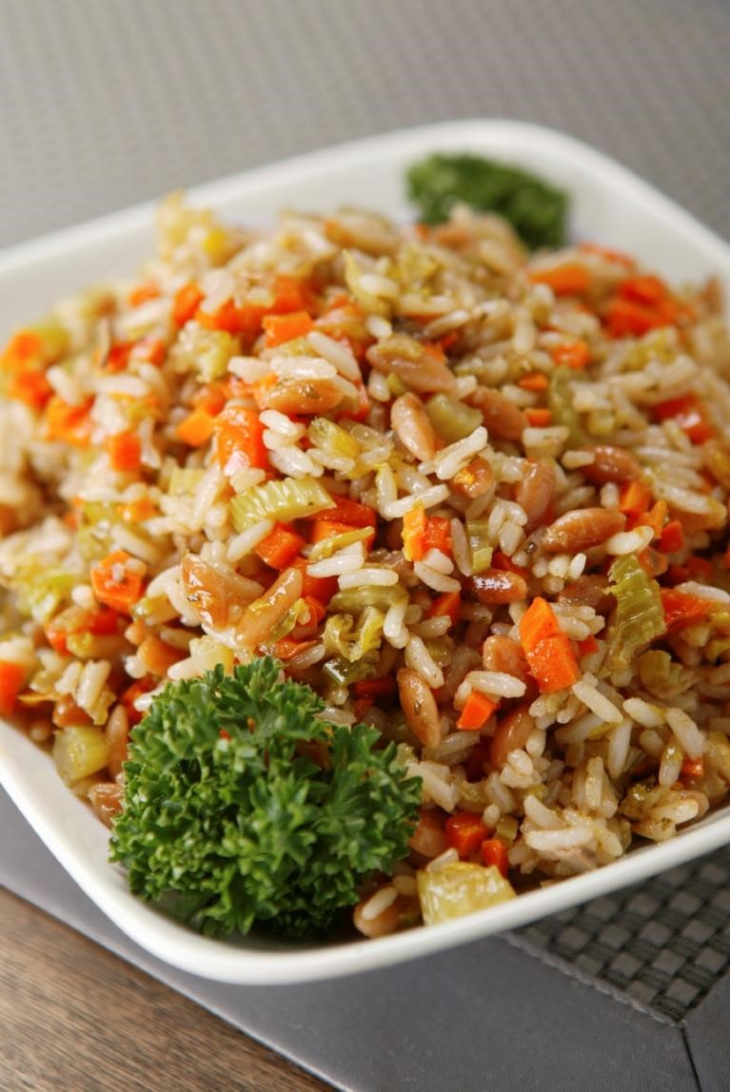

***GNFA Catering Department***

*tglass@gnfa.com*

*-*

*-*

478-224-3942



BUFFET DINNER

–

SELECTIONS

|  |
| --- |
| **Picnic Buffet**    Choice of 2:  Pulled Pork Barbecue  Southern Fried Chicken  Grilled Hamburgers  Grilled Jumbo Hot Dogs  **$15.95 per person**    BBQ Chicken Quarters  Grilled Smoked Sausage  **$17.95 per person**      Barbecue Ribs  Beef Brisket  Smoked Turkey Legs  Grilled or Fried Pork Chops  $**24.95 per person**    Choice of 2  Brunswick Stew  Baked Beans  Macaroni & Cheese  Broccoli Casserole  Squash Casserole  Corn Cobettes  Potato Salad  Cole Slaw    Assorted Breads & Rolls  Assorted Cookies  Iced Tea or Lemonade          GNFA’s Hog Heaven Pork Sandwich  Baked Beans  Coleslaw  **$9.95 per person**    **Desserts**  Please refer to our Desserts & Snacks Menu for a variety of options that can be added to the above packages  (Quoted accordingly.)    **Whole Pig Roast**  Dressed in Potatoes, Onions, Pears, Apples & Oranges  (Quoted accordingly.) |

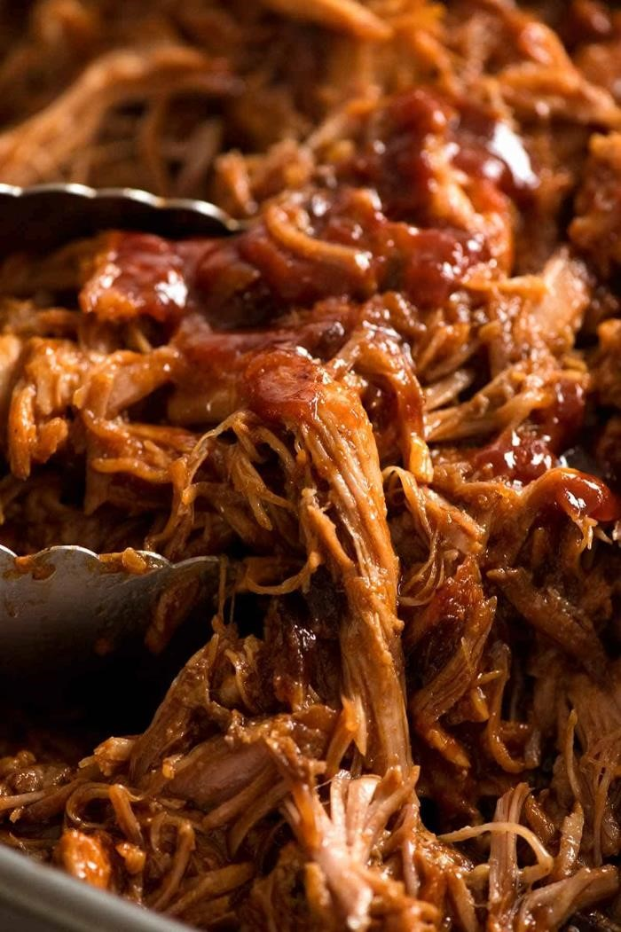



PICNICS & BARBECUES