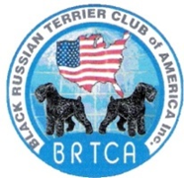

The Black Russian Terrier Club of America
will host
Judges Education Seminar at the Peach Blossom Cluster
Presented by Susan D. Scholar, BRTCA Judges Mentor
3:00 PM Wednesday, April 13, 2022
Georgia National Fairgrounds and Agricenter
Room TBD Perry, GA
Registration Fee of $35.00 includes the BRTCA Illustrated Standard
Pay via PayPal to brtca@bellsouth.net or make checks payable to
Black Russian Terrier Club of America, Inc. and mail to
Diana Evans
3889 Shiloh Trail West NW
Kennesaw, GA 30144
Please contact Diana Evans at BRTDianaEvans@aol.com,
subject line: BRTCA Judges Education, with your name and Judge’s Number
once you have paid your Registration Fee. On-site Registration
will also be available as space permits.

