HEALTH SEMINAR - Thursday, April 14th at 8:00 p.m
Make Plans to attend the
American Pointer National Specialty Health Seminar
Thursday, April 14th at 8:00 p.m.
Seminar will be held on the show grounds (specific location TBA)
Admission for Non-APC Members is $10.00 (pay at the door)

TITER TESTING & VACCINATIONS
Presented by Dr. Laurie Larson
• Canine Vaccine 101
• Canine titer testing – vaccine benefit versus risk
• Using nomograph analysis of breeding dam titers to
improve puppy immunization outcomes
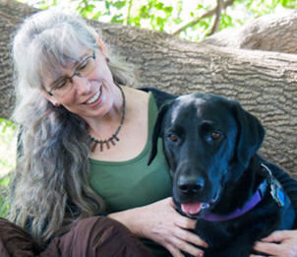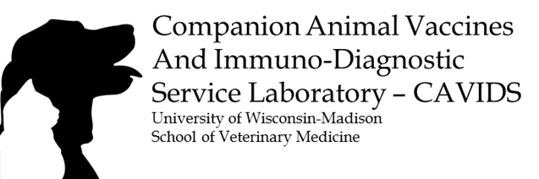
Dr. Laurie Larson with her dog, Soko
After five years in clinical veterinary practice, Laurie Larson, DVM joined the laboratory of Dr. Ronald Schultz at the University of Wisconsin-Madison, United States. Until his retirement in 2016, Dr. Larson studied canine and feline immune responses to vaccines and infectious diseases under Dr. Schultz’ mentorship, eventually becoming a co-investigator with him. As current director of the Companion Animal Vaccines and Immuno-Diagnostics Service (CAVIDS) Laboratory, Dr. Larson enjoys providing titer testing and consultation for veterinarians, dog breeders, pet owners, and animal shelters. She is pleased to be able to carry on Dr. Schultz’s important work in small animal immunology. Helping to improve the health and well-being of dogs and cats by serving the people who care for them is her life’s work and passion. She lives in Madison, Wisconsin.

