Don’t Miss these 2 Important Seminars with Dr Carmen Battaglia
The Peach Blossom Cluster & Charlene F. Madison, PhD proudly present a
Seminar with Dr. Carmen Battaglia
Topics: Pedigree analysis and the 8 Breeder Skills,
Learn how to breed by direction, not by chance using
pedigree analysis and the 8 skills of a breeder
Open to ALL Peach Blossom Cluster Exhibitors and the Public
Thursday April 14, 2022 6pm-9pm Perry, GA
Registration Fee: $25 - Please pre-register for the seminar by sending the fee
via PayPal to peachblossomcluster@gmail.com
Indicate in the note that the payment is for the Battaglia seminar and include the attendees’ names.
Registration will be available on-site at the Cluster office
if space is available.
Dr. Battaglia's books, software and DVDs will be available for sale at this event.
Please bring a pen, paper and pedigree. See Dr. Battaglia’s website at www.breedingbetterdogs.com
Light refreshments immediately prior to the seminar provided by
Over The Moon Black Russian Terriers and ZolaRoza Black Russian Terriers
For more information, contact Layne Shipley Townsend
bkshipley@icloud.com 470.629.4867

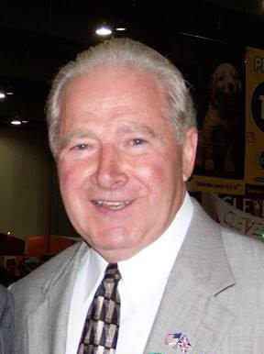
Free Seminar with Dr. Carmen Battaglia
Making Puppies Better
Topics: Learn how to choose the best puppies and make them better using nutrition, early neurological stimulation and research findings. Learn what to do as soon as you breed your female and how to improve your puppy’s development.
Sponsored by the Great Dane Club of the Mid-South
Friday, April 15, 2022, 7:30 - 9:00 p.m.
Lecture Hall - Miller Murphy Howard Building
Bring paper and pencil

